Solution Architecture Design (SAD)
1. Project Overview
Project Title: Cloud-Native Smart Door Security System with Biometric Access Control on Google Cloud Platform
This project delivers a secure, cloud-native IoT smart door security solution that enables real-time video/audio monitoring, two-way communication, biometric-based access control (face and fingerprint), remote unlocking, threat detection, and compliant data retention. The system is designed using Google Cloud Platform (GCP) services and follows zero-trust and privacy-by-design principles.

2. Business Objectives
- Provide secure, remote door access management
- Enable real-time visitor monitoring and two-way communication
- Support biometric authentication (face and fingerprint)
- Detect and respond to physical threats
- Maintain auditable access logs
- Ensure GDPR-compliant data retention and deletion
- Achieve scalable, event-driven cloud architecture

3. Functional Requirements
- Detect presence near door using camera and sensors
- Stream live video and audio to mobile application
- Support doorbell-triggered notifications
- Allow remote unlock after user authentication
- Enable local biometric unlock (face and fingerprint)
- Trigger alarm on unauthorized access or threats
- Record events, access attempts, and media
- Automatically delete stored data after 3 or 6 months

4. Non-Functional Requirements
- High availability and scalability
- Low latency for real-time interactions
- Strong security and encryption in transit and at rest
- Privacy-by-design for biometric data
- Auditability and traceability
- Cost-efficient storage and processing

5. Architecture Overview
High-Level Architecture Flow
Smart Door Device (Camera, Audio, Sensors, Biometrics, Lock)
→ HTTPS (TLS-secured REST APIs)
→ Google Cloud Pub/Sub
→ Cloud Run (Business Logic & Authorization)
→ Cloud Storage (Video & Audio)
→ Firestore (Users, Events, Access Logs)
→ Firebase Cloud Messaging
→ Mobile Application

6. Component Design
6.1 Edge / Device Layer
Components:
- Camera
- Microphone and Speaker
- Fingerprint Sensor
- Face Recognition Camera
- Touch and Door Sensors
- Lock Actuator
- Secure Enclave / TPM
Responsibilities:
- Capture video, audio, and biometric inputs
- Perform local biometric matching
- Enforce local PIN fallback
- Send telemetry and verification results to cloud
- Execute lock/unlock commands
Security Note: Raw biometric data never leaves the device.

6.2 Ingestion Layer
Protocol: HTTPS (TLS 1.2+)
Service: Google Cloud Pub/Sub
Responsibilities:
- Ingest device telemetry and events
- Decouple devices from backend services
- Enable scalable, event-driven processing

6.3 Processing & Business Logic Layer
Service: Cloud Run
Responsibilities:
- Validate device and user identity
- Evaluate access control policies
- Enforce multi-factor authentication
- Detect threats and anomalies
- Issue lock/unlock commands

6.4 Storage Layer
Cloud Storage
Purpose:
- Store video and audio recordings
Key Features:
- Encryption at rest
- Per-user bucket structure
- Lifecycle rules for auto-deletion
Firestore
Purpose:
- Store user profiles
- Store event metadata
- Store access logs and audit trails

6.5 Notification Layer
Service: Firebase Cloud Messaging
Responsibilities:
- Push notifications for:
  - Visitor detected
  - Doorbell pressed
  - Threat detected
  - Door unlocked

7. Biometric Authentication Design
Supported Methods
- Face Recognition
- Fingerprint Recognition
Design Principles
- Local biometric matching at the device
- No cloud storage of biometric templates
- Cloud receives verification result only
Unlock Policy Example
- Face + Fingerprint verified → Unlock
- Mobile app with MFA → Unlock
- Emergency PIN → Unlock

8. Security Architecture
- TLS encryption for all communications
- Device identity using certificates
- Zero Trust access model
- IAM least-privilege policies
- MFA for remote unlock
- Tamper and anomaly detection

9. Data Retention & Compliance
- Video/audio auto-deleted after 3 or 6 months
- Event logs use Firestore TTL policies
- GDPR-compliant data minimization
- Full audit trails via Cloud Logging

10. Monitoring & Observability
- Cloud Logging for events and errors
- Cloud Monitoring for system health
- Audit Logs for access and unlock actions

11. Cost Estimation (GCP Pricing Assumptions)
Note: Costs are indicative estimates for a small-to-medium deployment (e.g. 100–500 devices) and are based on typical usage patterns. Actual costs will vary by region and usage.
GCP Service | Assumption | Estimated Monthly Cost (GBP)
Cloud Run | ~2 million requests, moderate CPU/memory | £20 – £35
Pub/Sub | ~5 million messages/month | £5 – £10
Cloud Storage | ~1 TB video/audio storage with lifecycle rules | £15 – £25
Firestore | ~1M reads / 500k writes | £10 – £20
Firebase Cloud Messaging | Push notifications | £0 (Free)
Cloud Logging & Monitoring | Standard logs & metrics | £5 – £10
Estimated Total |  | £55 – £100 / month

12. Architecture Diagram
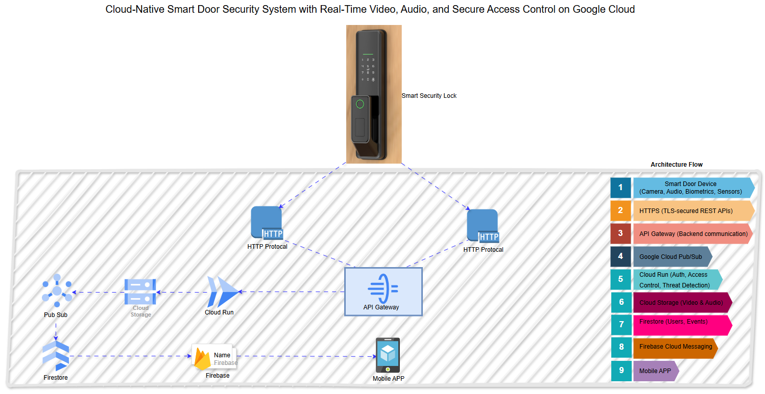The architecture diagram should visually represent:
- Smart Door Device (Camera, Audio, Biometrics, Sensors, Lock)
- Secure HTTPS communication
- Pub/Sub event ingestion
- Cloud Run business logic
- Cloud Storage for media
- Firestore for metadata and logs
- Firebase Cloud Messaging to Mobile App
Diagram Guidance:
- Use official GCP icons
- Clearly label protocols (HTTPS)
- Separate device, cloud, and mobile layers

13. Architecture Decision Records (ADRs)
ADR-001: Use HTTPS Instead of Native MQTT Service
Status: Accepted
Context:
GCP does not provide a native managed MQTT service following the deprecation of Cloud IoT Core.
Decision:
Use TLS-secured HTTPS APIs to ingest IoT telemetry into Pub/Sub.
Consequences:
- Fully managed and scalable ingestion
- Reduced operational overhead
- Slightly higher payload overhead compared to MQTT

ADR-002: Perform Biometric Matching at the Edge
Status: Accepted
Context:
Biometric data is highly sensitive and subject to strict privacy regulations.
Decision:
Perform face and fingerprint matching locally on the smart door device. Only verification results are sent to the cloud.
Consequences:
- Strong privacy guarantees
- Reduced cloud liability
- Requires more capable edge hardware

ADR-003: Use Cloud Storage for Media and Firestore for Metadata
Status: Accepted
Context:
Video and audio files are large and unsuitable for database storage.
Decision:
Store media files in Cloud Storage and store references and event metadata in Firestore.
Consequences:
- Cost-efficient storage
- High scalability
- Clear separation of data responsibilities

ADR-004: Adopt Event-Driven Architecture Using Pub/Sub
Status: Accepted
Context:
The system must handle asynchronous events such as doorbell rings, threat alerts, and access requests.
Decision:
Use Pub/Sub as the central event backbone.
Consequences:
- Loose coupling of components
- High scalability
- Easier future extension

14. Assumptions & Constraints
- Stable internet connectivity for cloud features
- Biometric hardware supports on-device matching
- Mobile app supports biometric and MFA authentication

12. Risks & Mitigations
Risk | Mitigation
Device tampering | Secure enclave, alerts
Network outage | Local PIN fallback
Data breach | Encryption, no biometric storage
Latency | Edge processing

